**DL Lab Report 1**

After extensive testing on the validation and test data, I found the following hyper-parameters giving the following errors (Train, Validation and Test Error):

1) Layers: 2 ReLU layers(100 units), 1 Linear layer(100 units) and 1 Softmax Output Layer

Epoch = 20, Learning Rate = 0.1, Batch Size = 256

Training Error = 6.7 %

Validation Error = 6.3 %

Test Error = 6.97 %

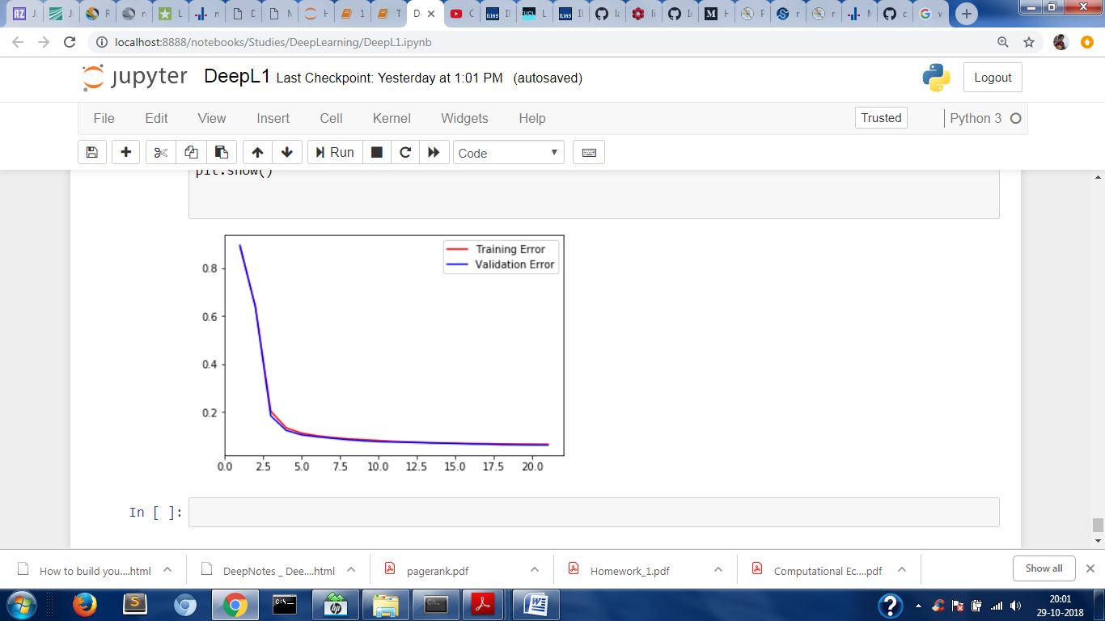

2) Layers: 2 Sigmoid layers(100 units), 1 Linear layer(100 units) and 1 Softmax Output Layer

Epoch = 50, Learning Rate = 1.5, Batch Size = 256

Training Error = 0.08 %

Validation Error = 2.32 %

Test Error = 2.42 %

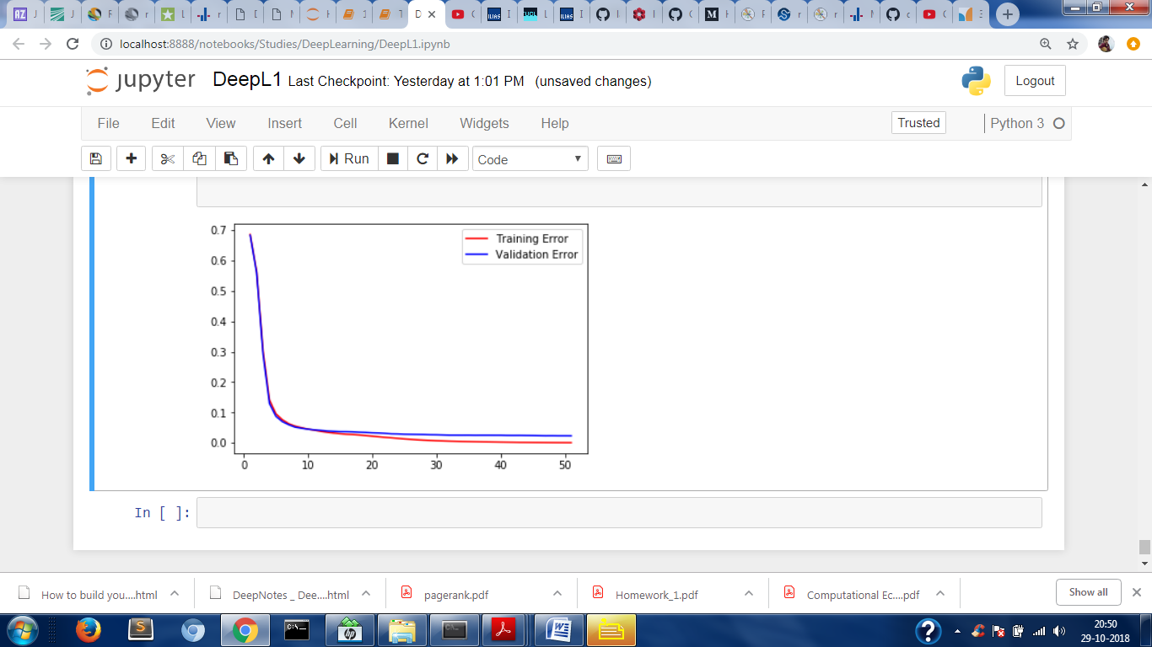

Observation: Previously, the errors were getting reduced very slowly. By increasing the learning rate from 0.1 to 1.5 the errors started decreasing with bigger margins.